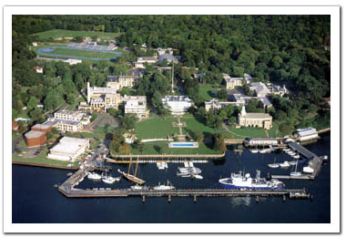
Come & Visit the Merchant Marine Academy
For Sophomores, Juniors and
Seniors in High School - Parents
Are Welcome too.
On: April 20th, 2011,Wednesday
Time: 11:00 am
Place: In Front of Melville Hall
Address: United States Merchant Marine Academy
300 Steamboat Road, Great Neck, NY 11024
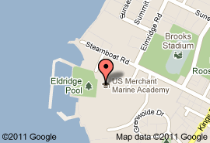
Directions: http://maps.google.com/maps?oe=utf-8&rls=org.mozilla:en-US:official&client=firefox-a&um=1&ie=UTF-8&cid=0,0,3307041901434918155&fb=1&hq=merchant+marine+academy&hnear=Mineola,+NY&gl=us&daddr=300+Steamboat+Road,+Great+Neck,+NY+11024&geocode=10041291367976976128,40.812272,-73.762643&ei=O8KVTbDgItO5tgfrnJzuCw&sa=X&oi=local_result&ct=directions-to&resnum=2&ved=0CEkQngIwAQ
Day Visit - Lunch with Midshipmen, and an escorted campus tour by Ann Chan. At that time, they may meet with an admission recruiter who will provide information and answer questions. Lunch in Delano Hall. We may attend afternoon classes with their escorts and finish at approximately 4 p.m. Since the Academy is not authorized to pay the cost of meals for visiting guests, those electing to come for a Day Visit are required to bring payment for their lunch with them. The cost is $16.00, which can be paid in cash.
RSVP by April 17th: call Betty Leong at 917-548-8185
or Email: leongba@yahoo.com
If you want to come but have no ride, we will try to arrange transportation.

